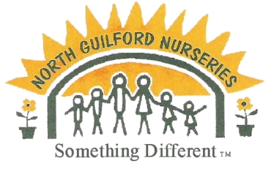

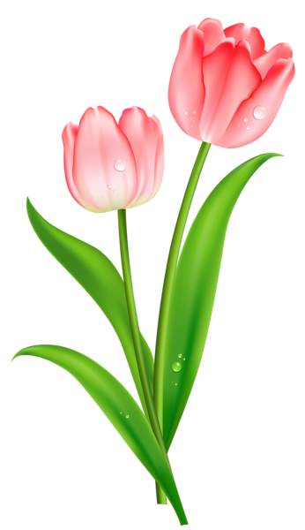 Locally Grown, Family Owned
North Guilford Nurseries
Mother’s Day Fundraiser

 |  | 10” Hanging Basket
Customer Name | Number | Growers Choice | Calibrachoa M.B. | Combination | Fuchsia | Geranium | New Gunea Imp | Petunia | Verbena | Amount | Received

Organization: Sellers Name: Pick Up Date:
*Make checks payable to organization above Be sure to place quantity in box. Some items may be substituted based on availability.
Pricing
10” Hanging Basket - $25

All Forms Must be turned in by:
________________
All Forms Must be turned in by:
________________

